**Setup *ManagementWebClient App* ( Angular App )**

***Prerequisite***

1. Visual Studio Code <https://code.visualstudio.com/download> **( User Installer 64 bit )**

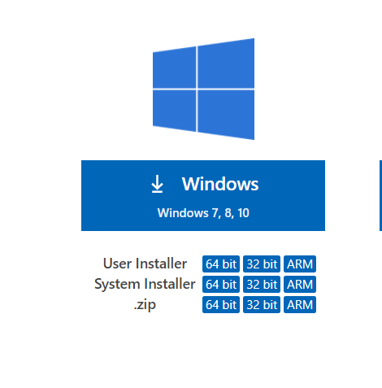

1. Node.js <https://nodejs.org/en/> **( 14.17.6 LTS )**

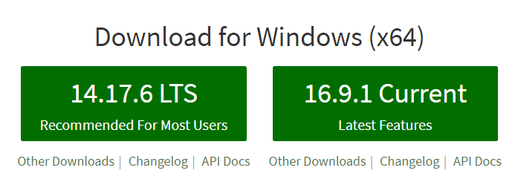

1. Angular CLI <https://www.npmjs.com/package/@angular/cli>
   1. Open *Command Prompt* and use below command to install *angular CLI*
   2. npm i -g @angular/cli

***Setup Clone Project ( CaaS )***

1. <https://dev.azure.com/civica-vadodara/CaaS/_git/Civica.CaaS.ManagementWebClient/branches>
   1. Click on **development** branch
2. To clone this project, go to **Clone** button located *top-right corner* and click it.

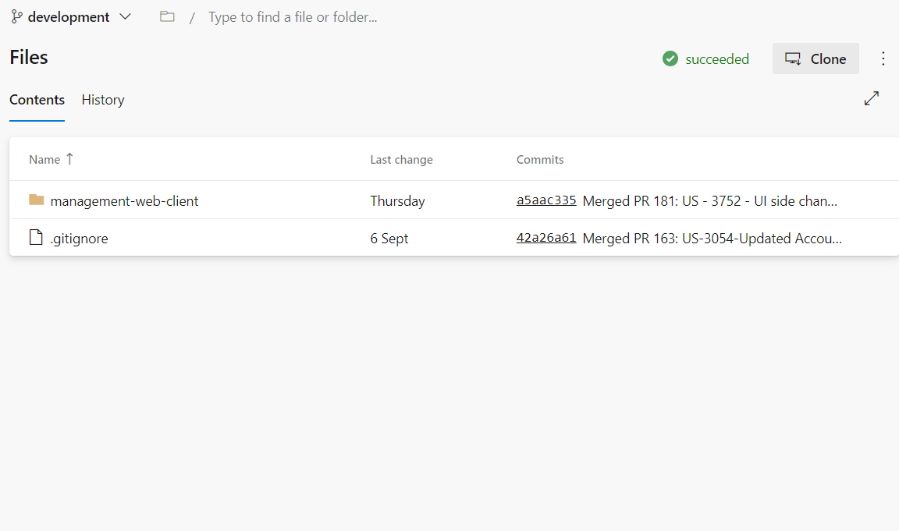

Copy the Link

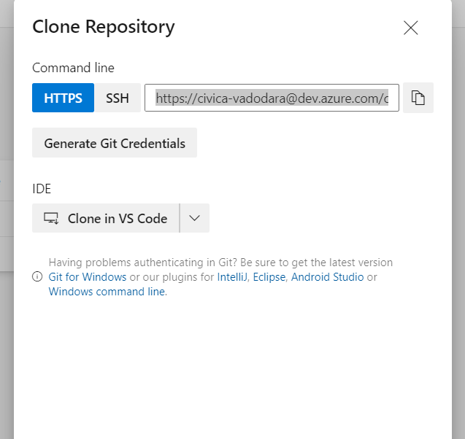

1. Open **Git Bash** in your machine.

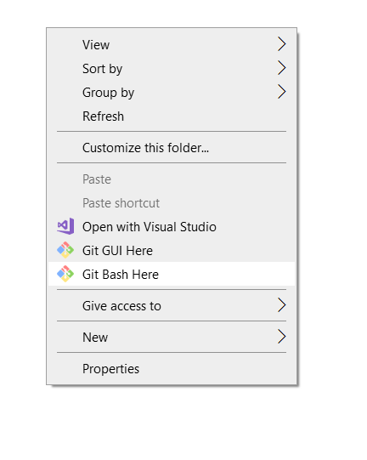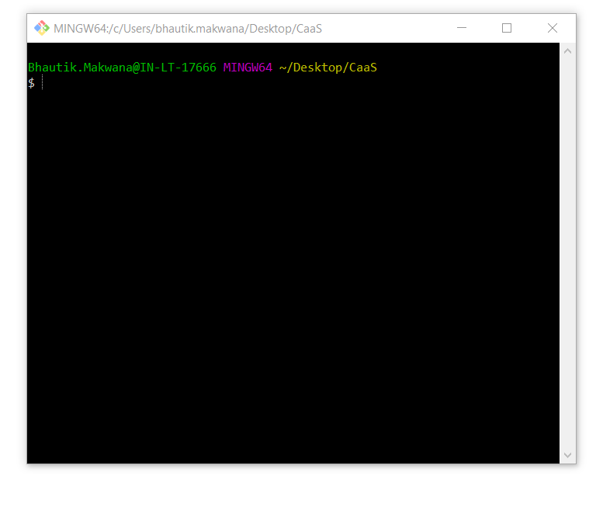

1. Use bellow command to *clone* the project
   1. **git clone <**Copied Link>

**Copied link –** <https://civica-vadodara@dev.azure.com/civica-vadodara/CaaS/_git/Civica.CaaS.ManagementWebClient>

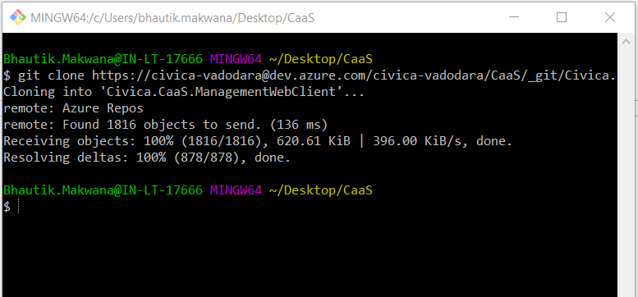

1. After Successful cloning open folder **management-web-client** in VS Code (Visual Studio Code)

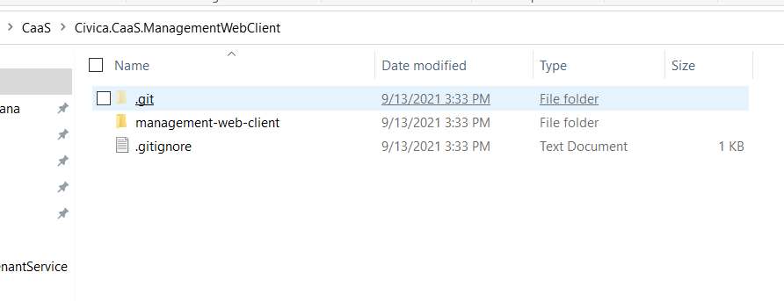

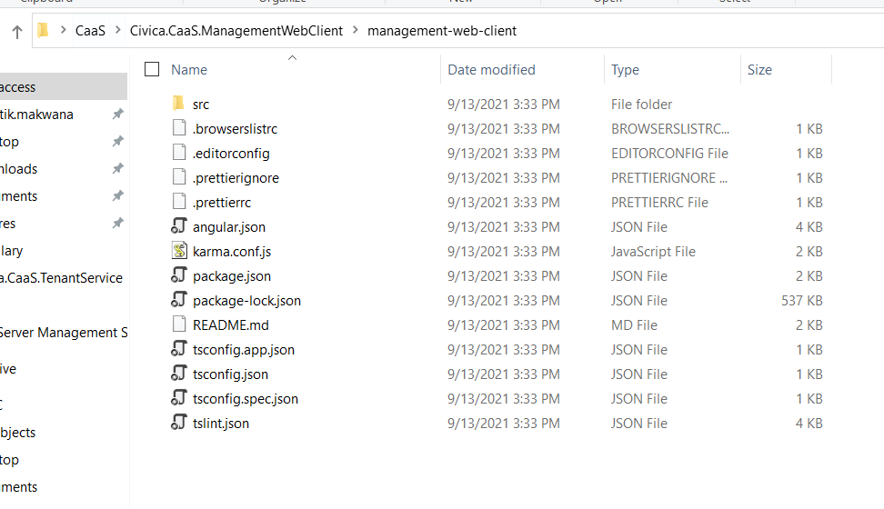

* 1. Short Cut method to open any folder in VS Code.
     1. Write **cmd** in folder path and press Enter key.

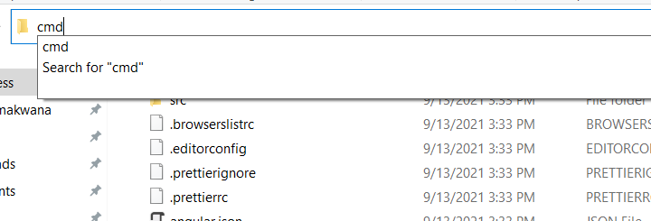

* + 1. Write this command in CMD and press Enter key
       1. **code .**

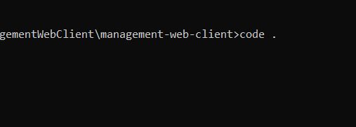

1. Create a new text file and **write a below code** in it and name it as a **certificate.cnf ( .cnf is an extensions of file )**in*management-web-client*folder

[req]  
default_bits = 2048  
prompt = no  
default_md = sha256  
x509_extensions = v3_req  
distinguished_name = dn  
[dn]  
C = GB  
ST = London  
L = London  
O = My Organisation  
OU = My Organisational Unit  
emailAddress = [email@domain.com](mailto:email@domain.com)  
CN = localhost  
[v3_req]  
subjectAltName = @alt_names  
[alt_names]  
DNS.1 = localhost

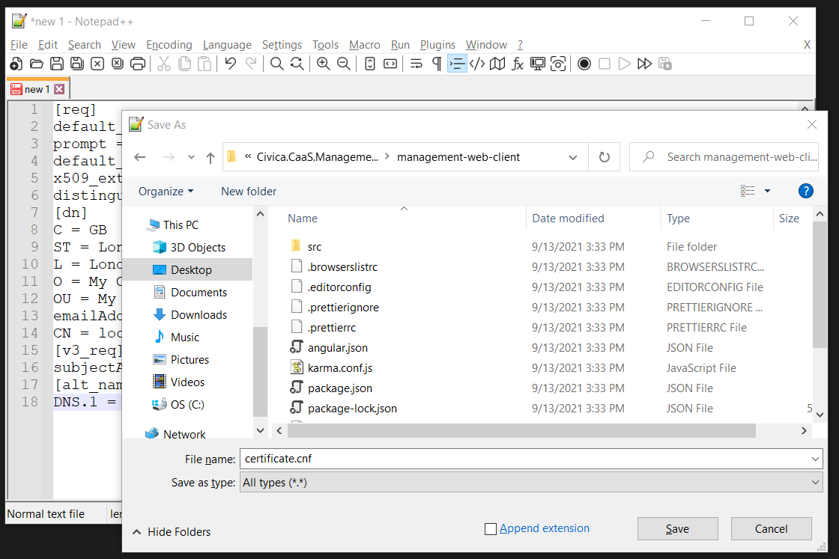

1. Open ***Git bash*** in ***Civica.CaaS.ManagementWebClient* folder** and use below command

openssl req -new -x509 -newkey rsa:2048 -sha256 -nodes -keyout localhost.key -days 3560 -out localhost.crt -config certificate.cnf

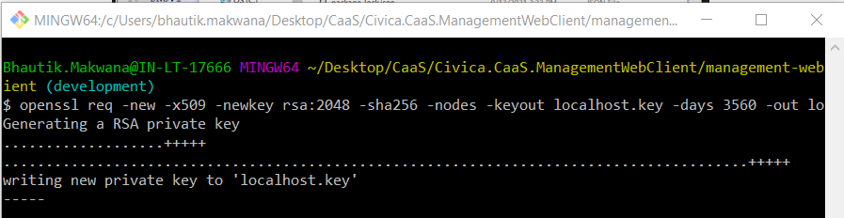

1. Open **management-web-client** in VS Code
   * 1. Open integrated terminal window **( Ctrl + ` )**
     2. Use this command to install node modules
        1. **npm install**

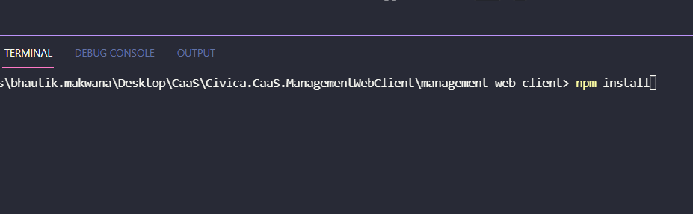

1. use below command in integrated terminal to run app **( Ctrl + ` )**
   1. *npm run start-secure*
2. Click on **Advance** button shown below and **Proceed to localhost (unsafe)**

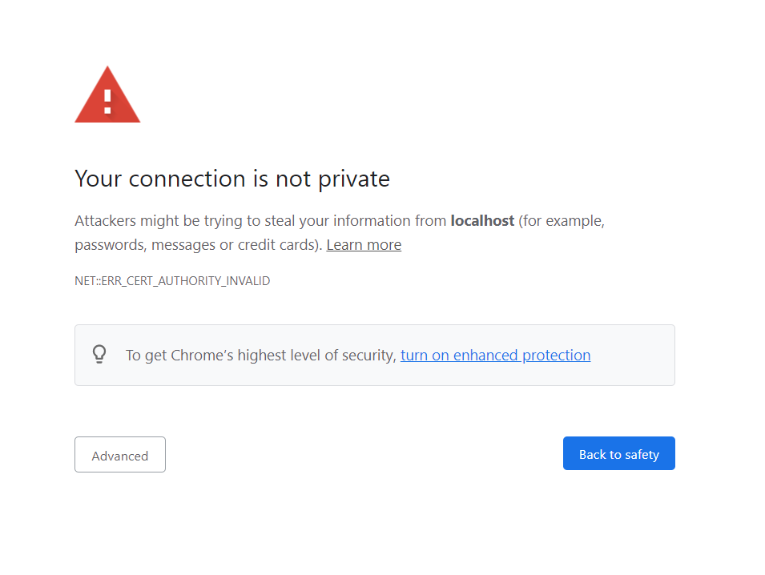

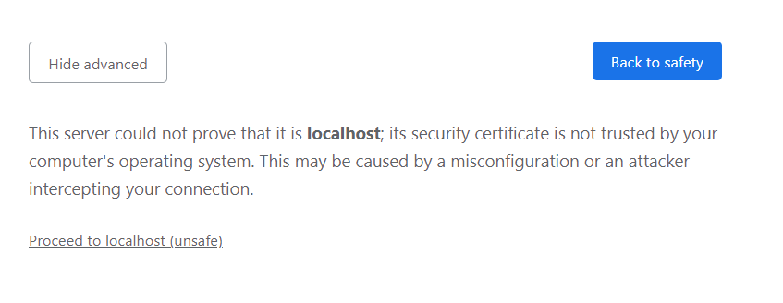

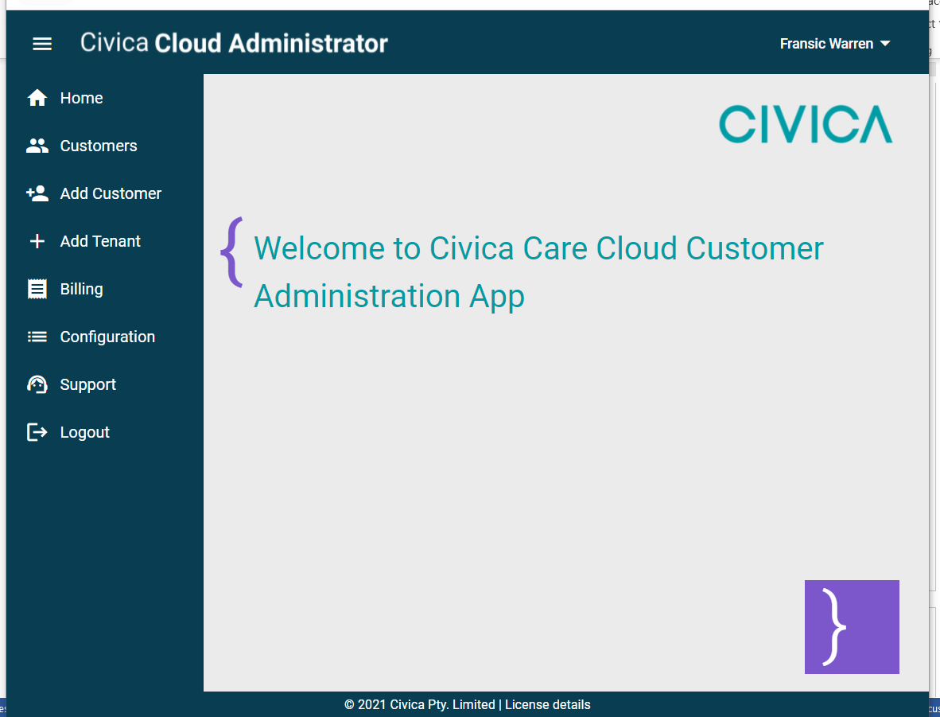

**Setup *TenantService App* (.Net Web App)**

***Prerequisite***

1. Microsoft Visual Studio **Professional** 2019
   1. <https://visualstudio.microsoft.com/vs/professional/>
2. Azure Functions Core Tools ( Azure Functions CLI )
   1. <https://docs.microsoft.com/en-us/azure/azure-functions/functions-run-local?tabs=windows%2Ccsharp%2Cportal%2Cbash%2Ckeda#install-the-azure-functions-core-tools> **( v3x – Windows 64-bit )**

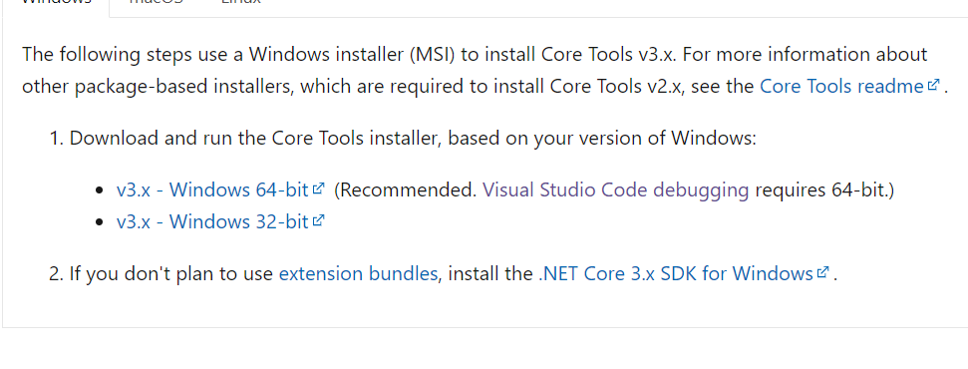

***Setup Clone Project***

1. <https://dev.azure.com/civica-vadodara/CaaS/_git/Civica.CaaS.TenantService/branches>
   * Select **All** branch and select **develop** branch

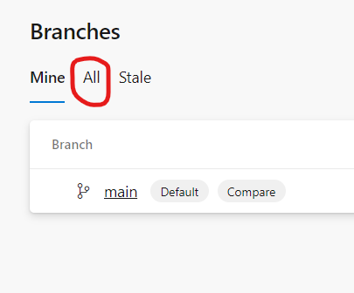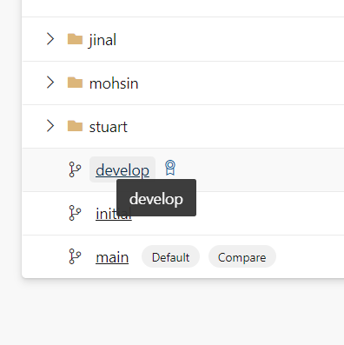

1. Click on **Clone** button on *top right corner* and Copy the Link and clone it in your machine

Link - <https://civica-vadodara@dev.azure.com/civica-vadodara/CaaS/_git/Civica.CaaS.TenantService>

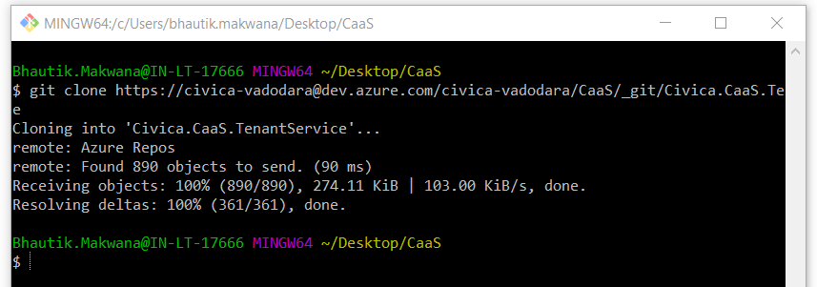

1. Open **Cloned folder** in Visual Studio Shown below i.e. *Civica.CaaS.TenentService*

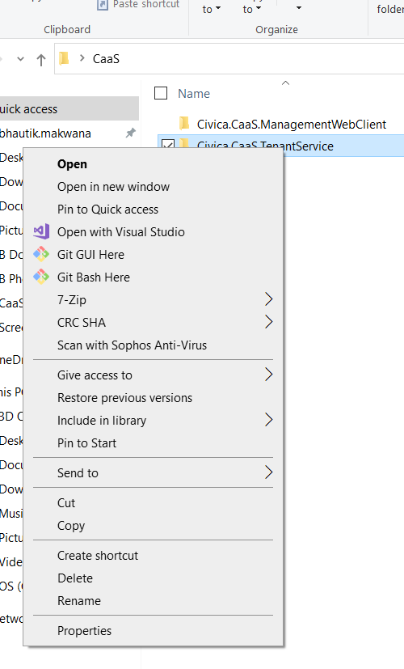

1. Click below icon

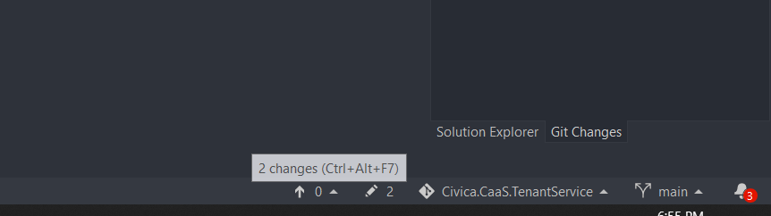

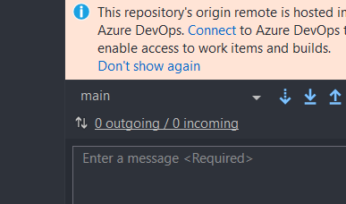

1. Click on **Checkout develop** branch as shown below

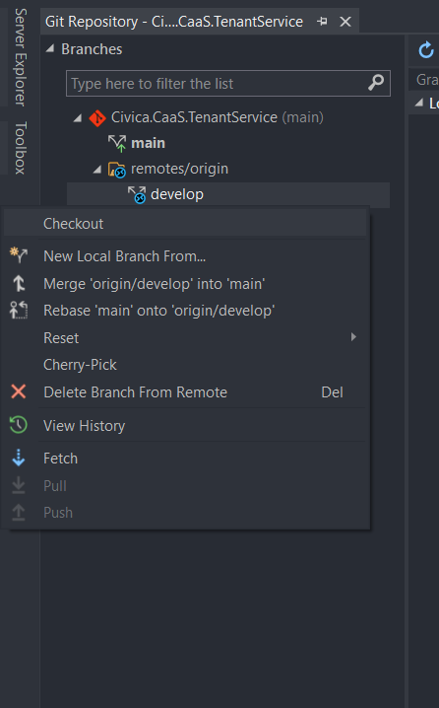

1. **Fetch** that branch

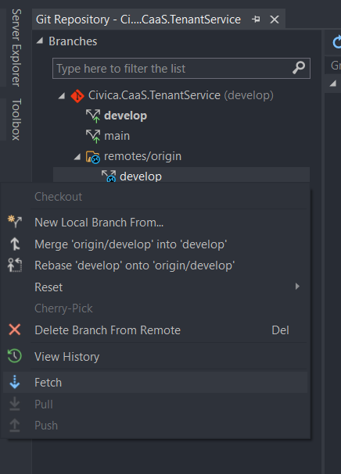

1. Open Solution Explorer and you will see below Project files

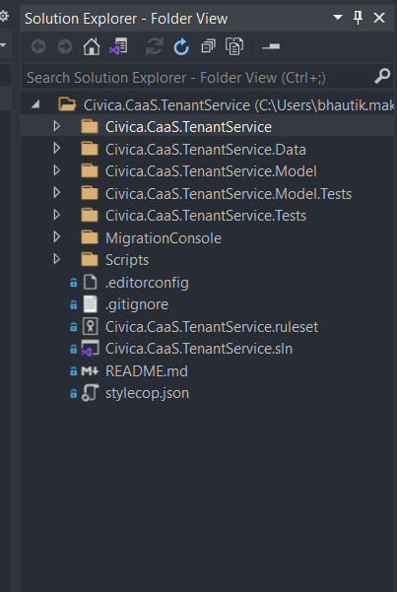

1. Click on **.sln** file to open it

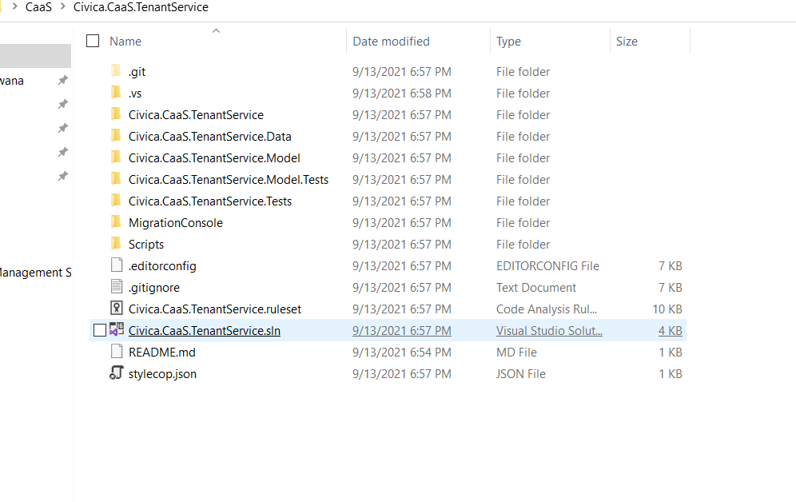

1. Right click on *Project Solution* and Build Solution to restore all packages

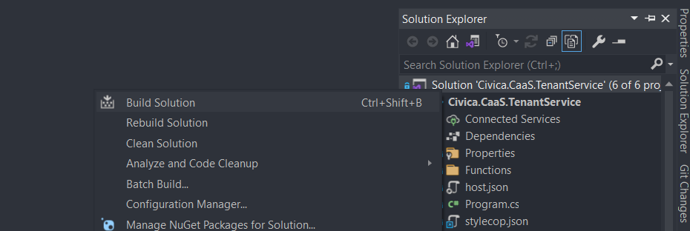

1. Open Tools and click on Options

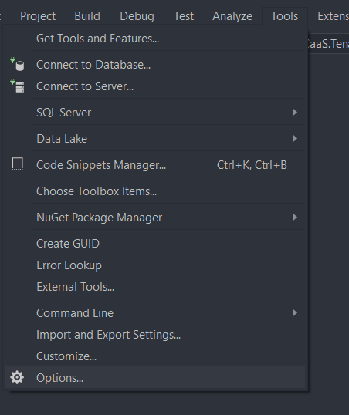

1. Select NuGet Package Manager From *option* make sure settings should be as below

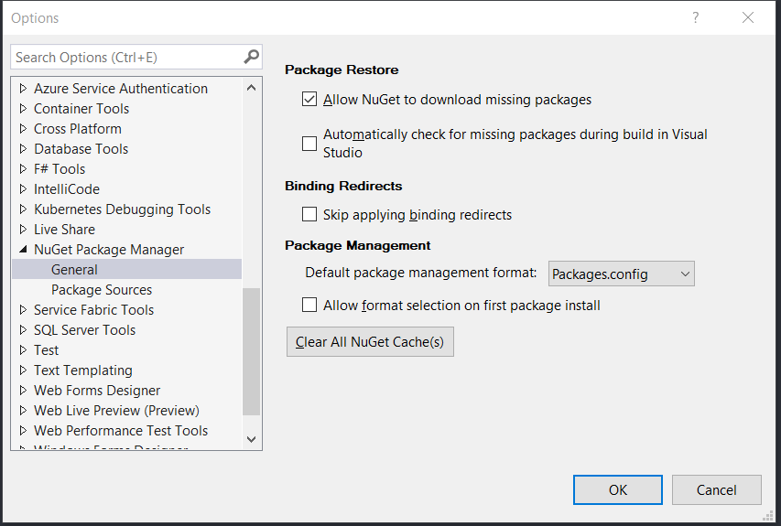

1. *Package sources* should contain these packages

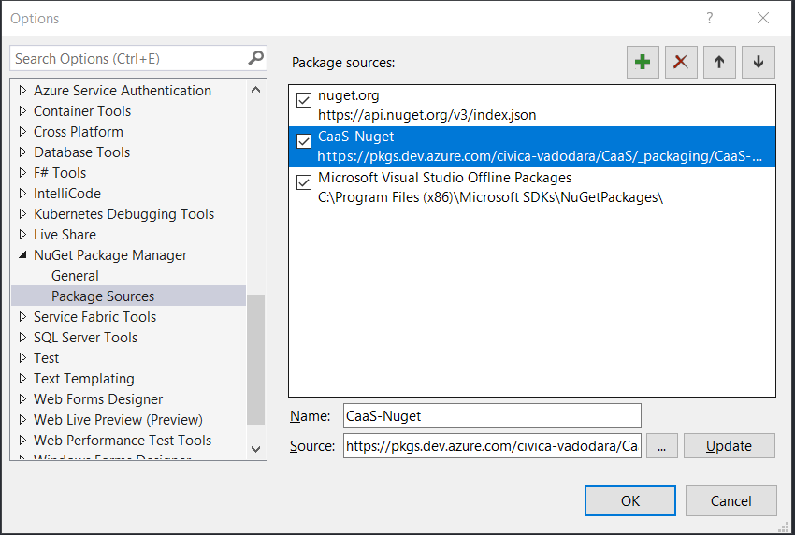

1. Incase if there is not CaaS-NuGet in *package sources* then don’t forget to add it.
   * *Name* : **CaaS-NuGet**
   * *Source* : [**https://pkgs.dev.azure.com/civica-vadodara/CaaS/_packaging/CaaS-Nuget/nuget/v3/index.json**](https://pkgs.dev.azure.com/civica-vadodara/CaaS/_packaging/CaaS-Nuget/nuget/v3/index.json)
2. Run Project

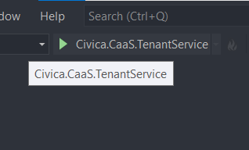

1. Boom ! Projects is running successfully

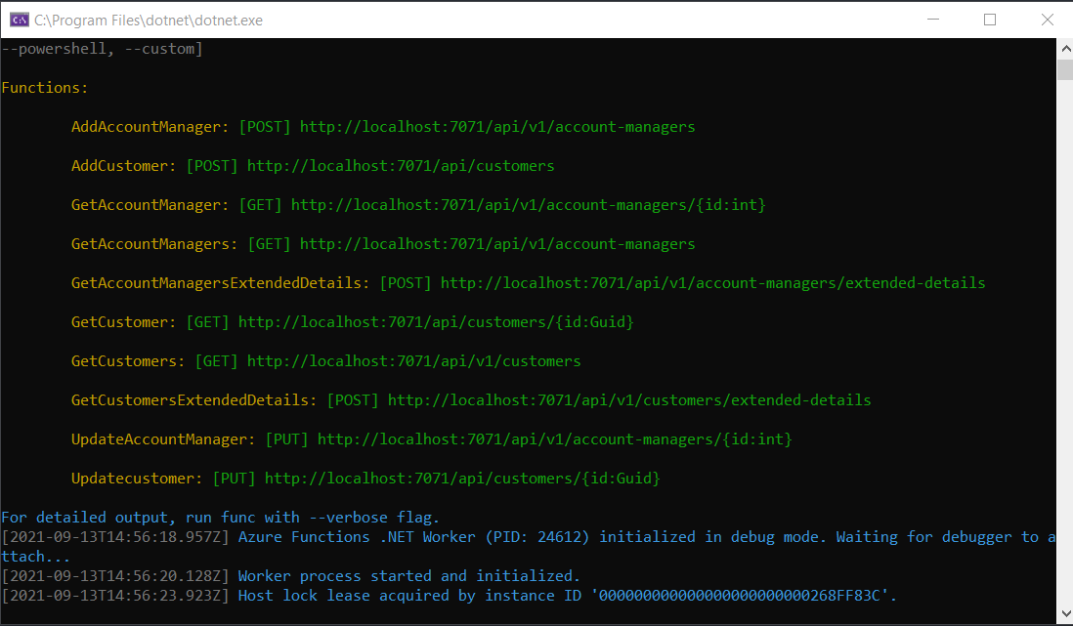

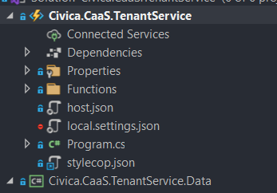

1. If there is not a **local.setting.json** file present there as shown above image then create a new file name as mention ( local.setting.json where *.json is extension* ) and write below code there and rebuild the solution.

* In ConnectionStrings change the name of *Server* as your machine server name

{

"IsEncrypted": false,

"Values": {

"AzureWebJobsStorage": "UseDevelopmentStorage=true",

"FUNCTIONS_WORKER_RUNTIME": "dotnet-isolated",

"ENVIRONMENT": "DEVELOPMENT",

"AzureB2C__ClientId": "cf2973fe-ba8c-4200-bf27-e46513dd6174",

"AzureB2C__Domain": "coldharbourcaasdevtest.onmicrosoft.com",

"AzureB2C__Instance": "https://coldharbourcaasdevtest.b2clogin.com",

"AzureB2C__SignUpSignInPolicyId": "B2C_1_dev_signin",

"AzureB2C__TenantId": "c2715fac-0f02-485b-9dc0-5d567d8cb541"

},

"Host": {

"LocalHttpPort": 7071,

"CORS": "*"

},

"ConnectionStrings": {

"BaseConnectionString": "Server=Your_Server_Name;Database=civica-TenantManagement;Trusted_Connection=True;"

}

}

1. Open the *Packager Manager Console* from Tools

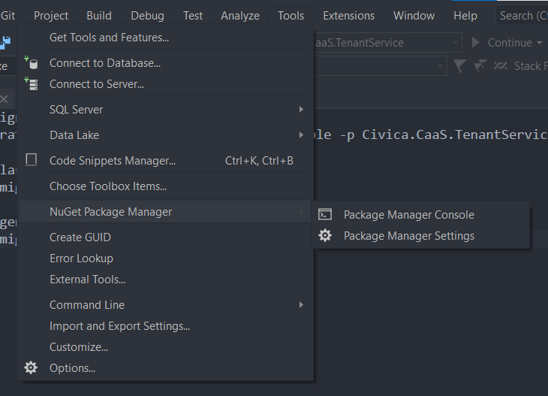

1. Run below command in console, make sure *Default project* should be MigrationConsole

script-migration -s MigrationConsole -p Civica.CaaS.TenantService.Data

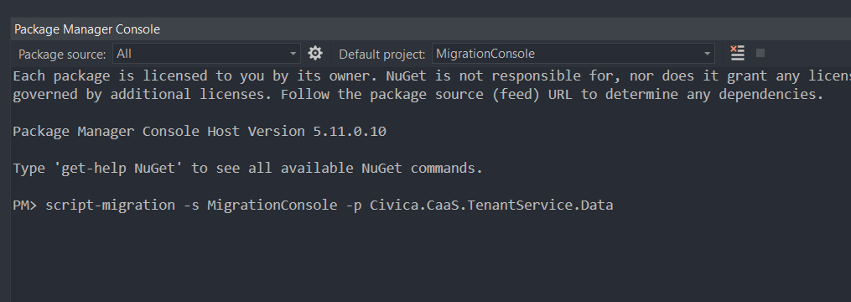

1. After successfully running the command this kind of script would generate.

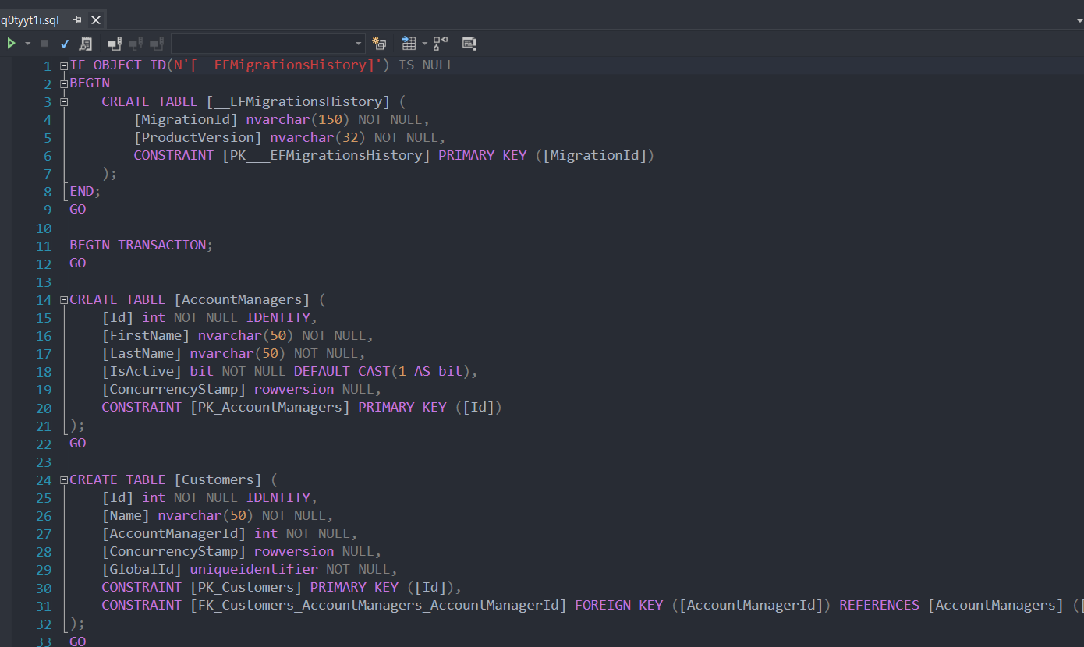

1. Open *Microsoft SQL Server Management Studio* and *create a new data base* name of

civica-TenantManagement

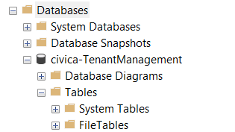

1. Create a New Query and *copy - paste that generated script*.

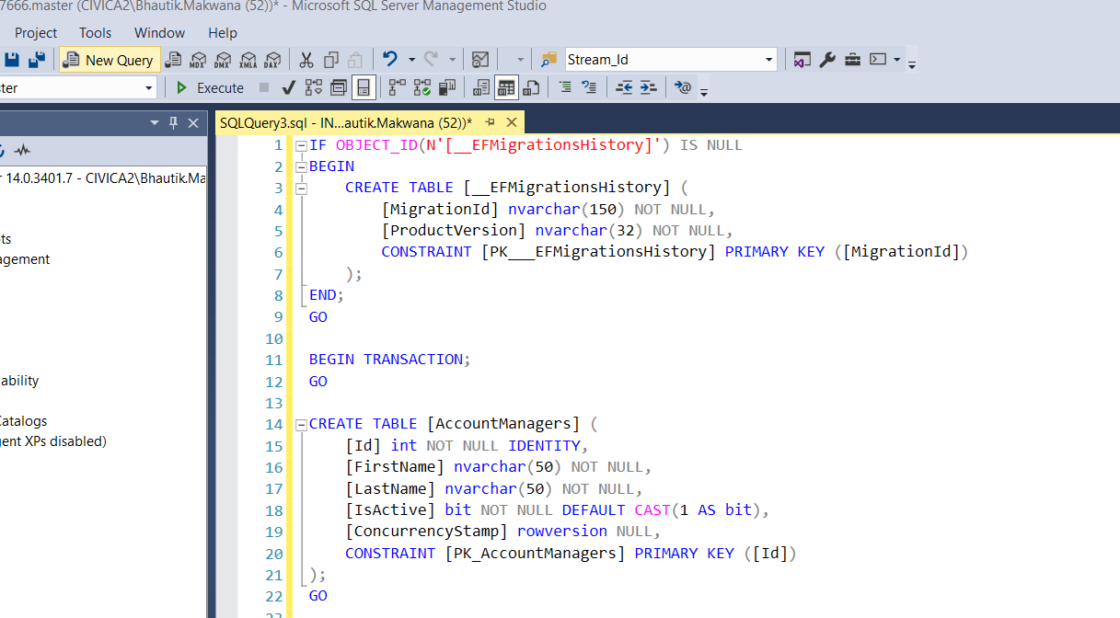

1. After Executing query file *tables* will be added in your civica-TenantManagement DB

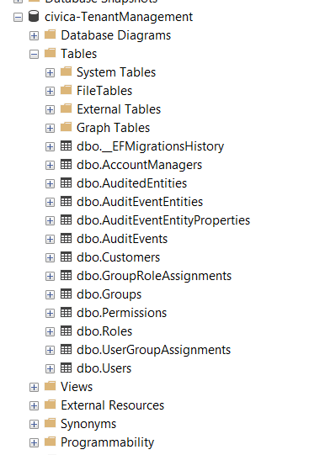

1. Now, Again Rebuild the solutions and run the project.